1. Basic Git Commands (For managing repositories)
      - git init: Initializes a new Git repository in the current directory.

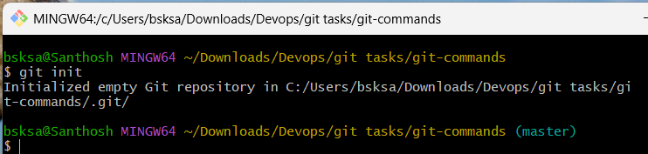

- git clone <repo_url>: Clones a repository from a remote URL to your local machine.

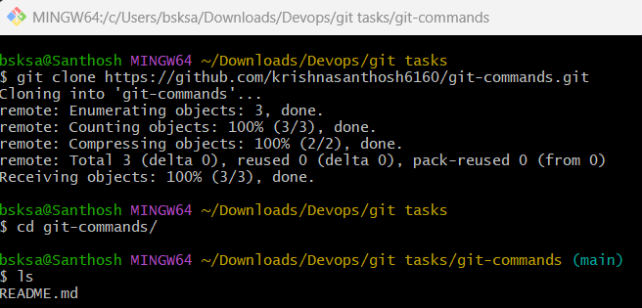

- git status: Shows the working directory status (which files are modified, staged, etc.).

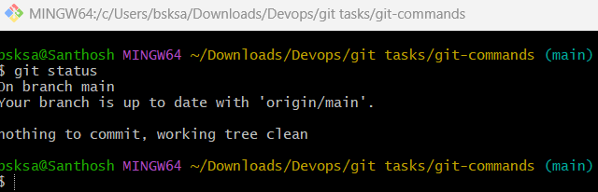

- git add: Stages a file or files to be committed.

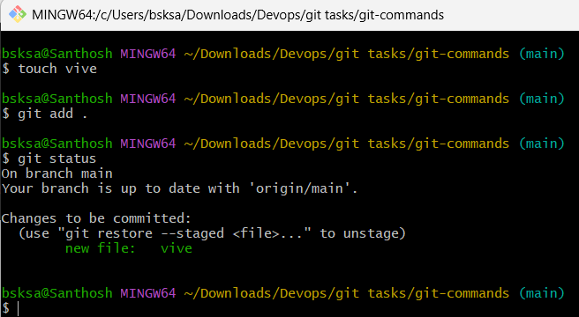

- git commit -m "message": Commits staged changes to the local repository with a message.

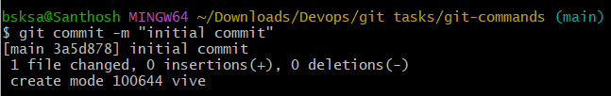

- git push: Pushes committed changes to the remote repository.

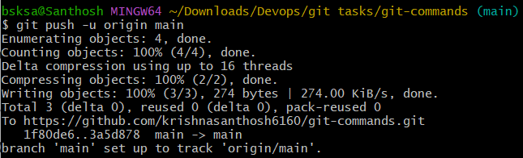

- git pull: Fetches and merges changes from the remote repository to your local working directory.

- Create a file in github and using git pull command pull the changes to the local machine.

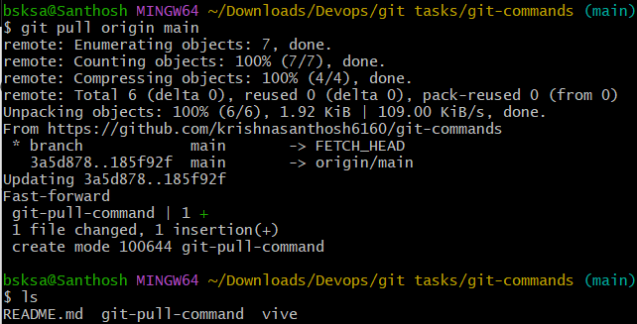

- git fetch: Downloads objects and refs from another repository (without merging).

- create a new branch “feature1” on github and use fetch command on local machine.

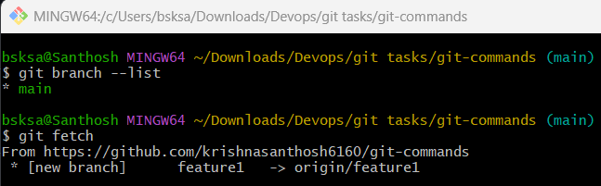

- git merge: Merges changes from the specified branch into the current branch.

Add a file in feature1 branch and commit it.
Switch to main branch and merge feature1 with main branch.
Hence the file created in feature1 branch is reflected in main branch.

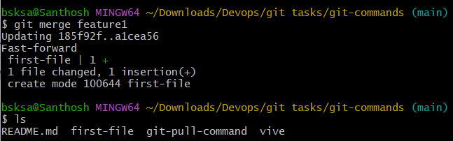

- git log: Shows the commit history of the repository.

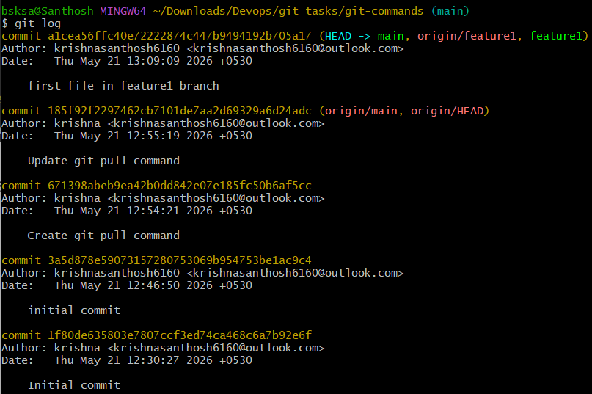

- git diff: Shows the differences between your working directory and the index (staged changes).

- Add content to the already existing file and use git diff command to check the current to that of already staged changed changes of the same file.

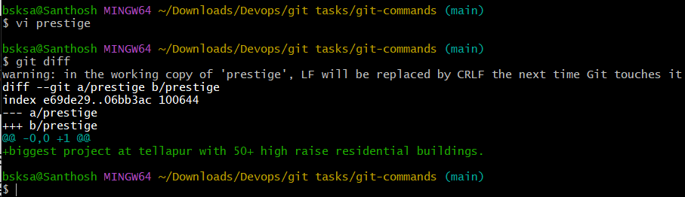

2. Branching Commands (Managing branches)
- git branch: Lists all branches in your repository.

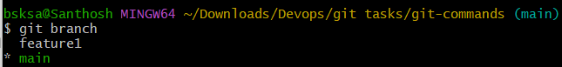

- git branch <branch_name>: Creates a new branch.

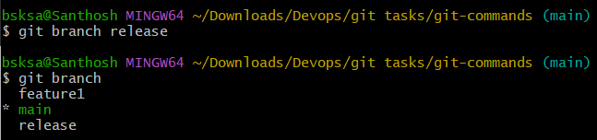

- git checkout <branch_name>: Switches to an existing branch.

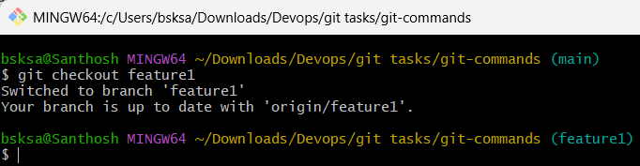

- git checkout -b <branch_name>: Creates and switches to a new branch in one step.

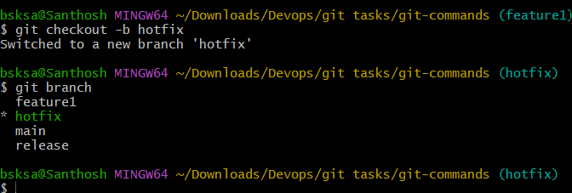

- git merge <branch_name>: Merges changes from the specified branch into the current branch.

- Add a file in feature1 branch and commit it.
- Switch to main branch and merge feature1 with main branch.
- Hence the file created in feature1 branch is reflected in main branch



- git rebase <branch_name>: Applies changes from one branch onto another branch (instead of merging).

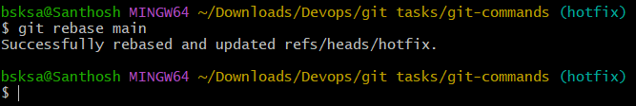

- git branch -d <branch_name>: Deletes the specified branch (locally).

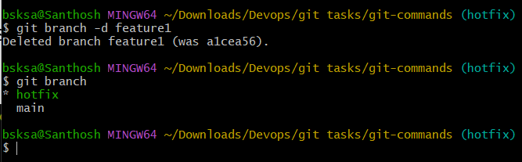

- git branch -D <branch_name>: Forcefully deletes a branch (locally).

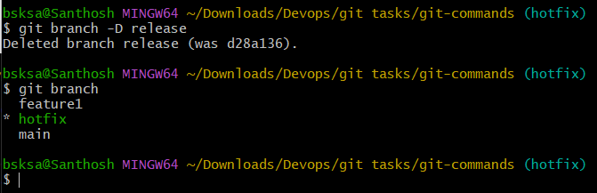

- git remote set-head origin <branch_name>: Sets the default branch for the remote repository.

3. Remote Commands (Managing remotes and syncing with the cloud)

- git remote -v: Shows the remote repository URLs.

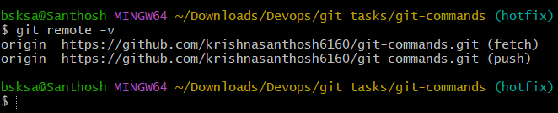

- git remote add: Adds a new remote repository.

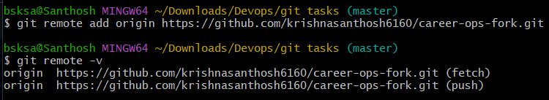

- git remote remove: Removes a remote repository.

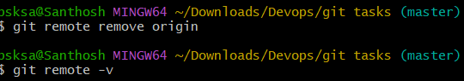

- git push origin <branch_name>: Pushes a branch to a remote repository.

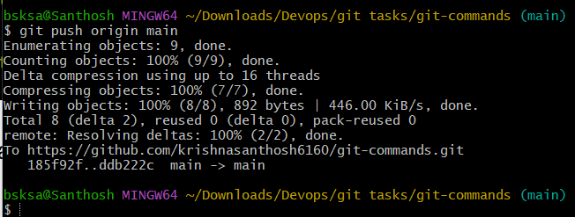

- git push -u origin <branch_name>: Pushes a branch to a remote repository and sets the upstream for the branch.

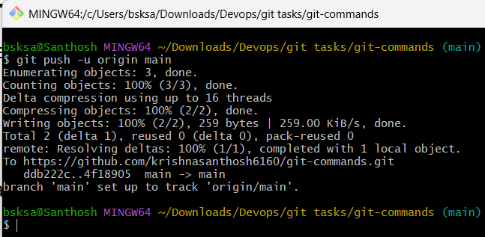

- git pull origin <branch_name>: Fetches and merges a branch from the remote repository.

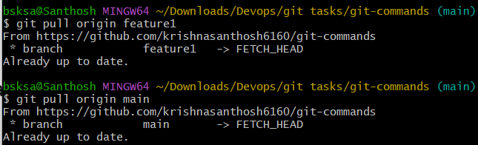

- git fetch origin: Downloads objects and refs from the remote repository.

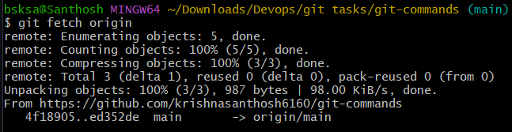

- git remote show origin: Displays detailed information about a remote repository.

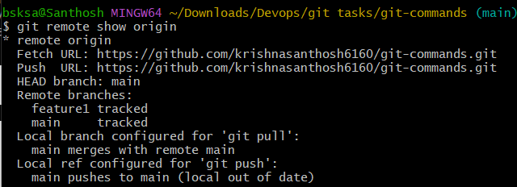

4. Staging and Committing (Managing changes)

- git add . : Stages all modified files in the working directory.

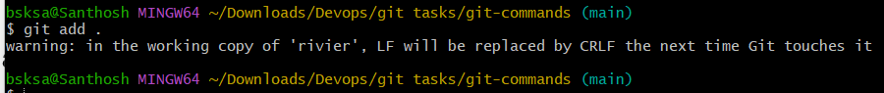

- git add -A: Stages all modified files (including file deletions).

- git reset: Unstages a file (reverts it to the working directory).

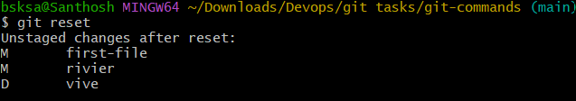

- git commit --amend: Modifies the last commit (can change the commit message or add changes).

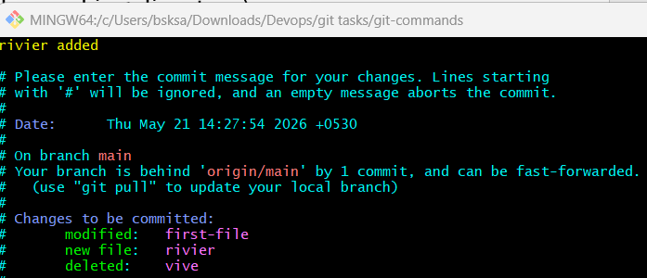

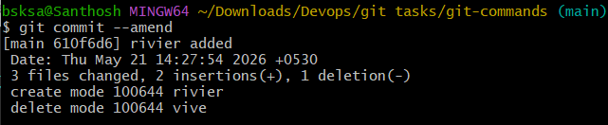

- git commit --all: Automatically stages tracked files and commits them.

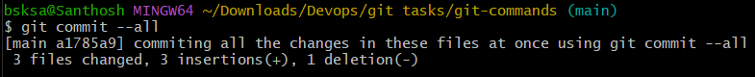

- git commit -a: Stages and commits all modified files.

- git commit --no-verify: Skips pre-commit hooks while committing.
- git reset --soft HEAD~1: Moves the HEAD pointer back one commit but leaves your changes staged.

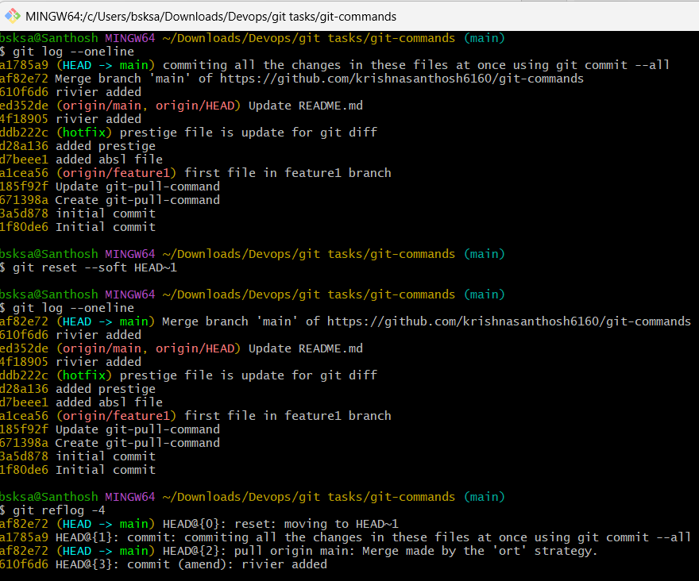

- git reset --hard HEAD~1: Moves the HEAD pointer back one commit and discards changes in the working directory.

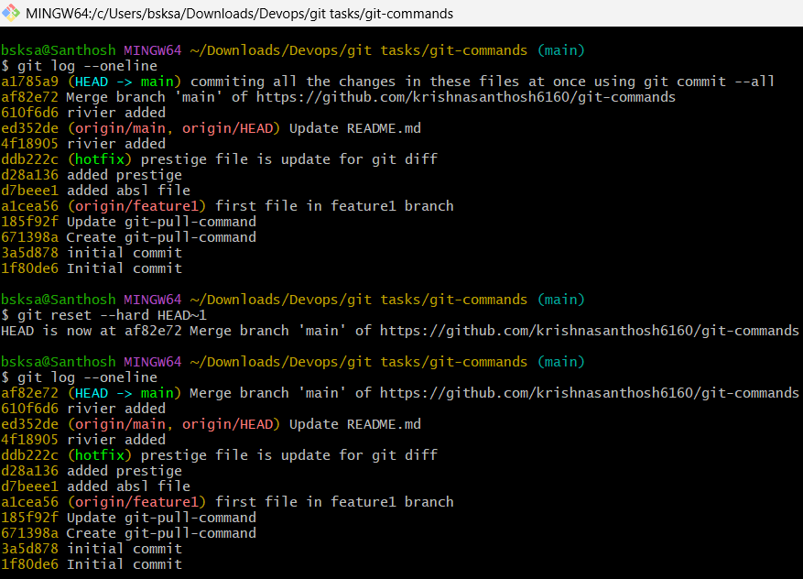

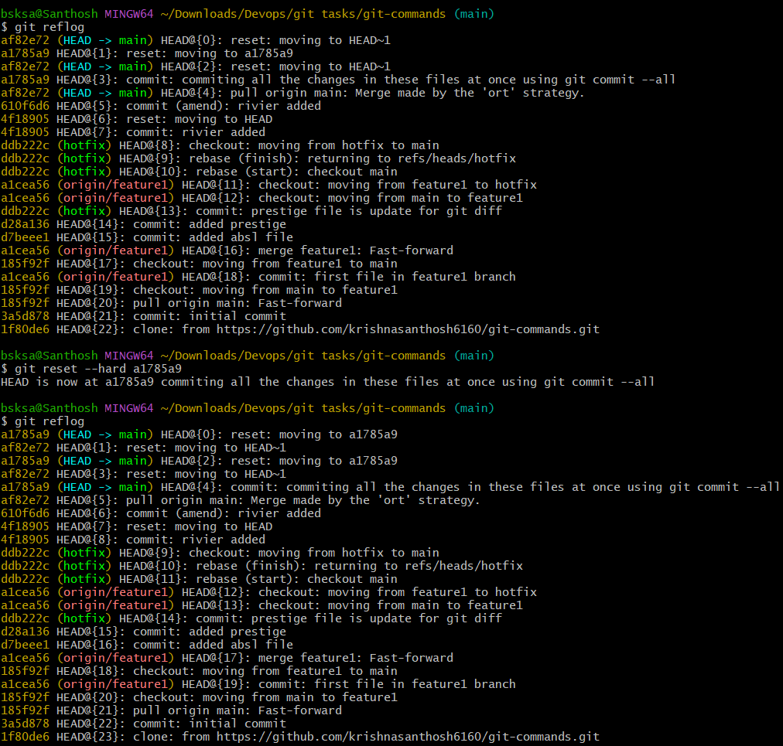

5. Viewing and Comparing Changes (Inspecting changes)

- git diff: Shows changes between your working directory and the index (unstaged changes).



- git diff --staged: Shows changes between the index (staged files) and the last commit.

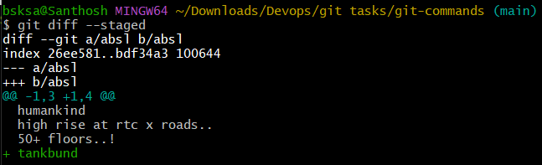

- git diff <commit_id>: Shows the differences between your working directory and a specific commit.

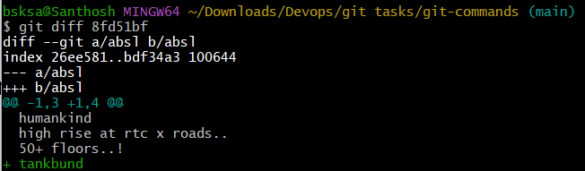

- git log: Displays the commit history.

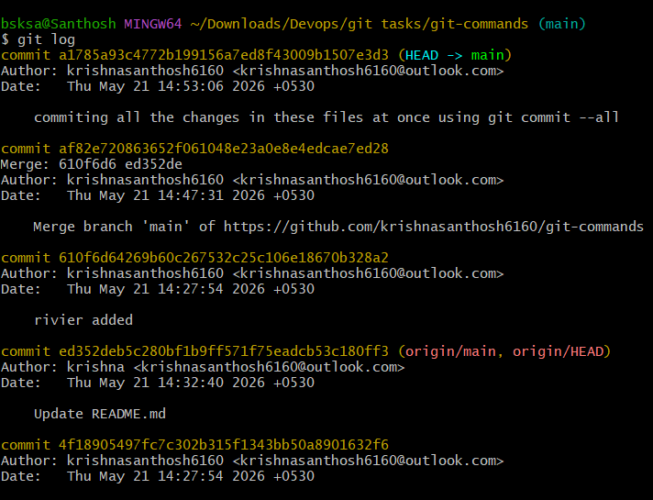

- git log --oneline: Displays the commit history in a simplified one-line format.

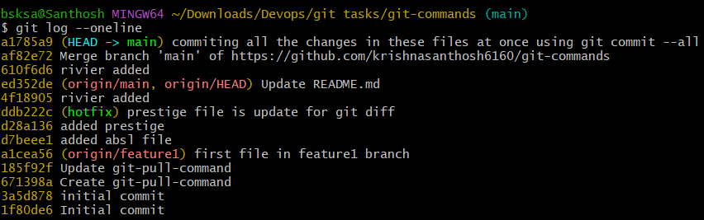
- git log --graph: Displays the commit history as a graph.

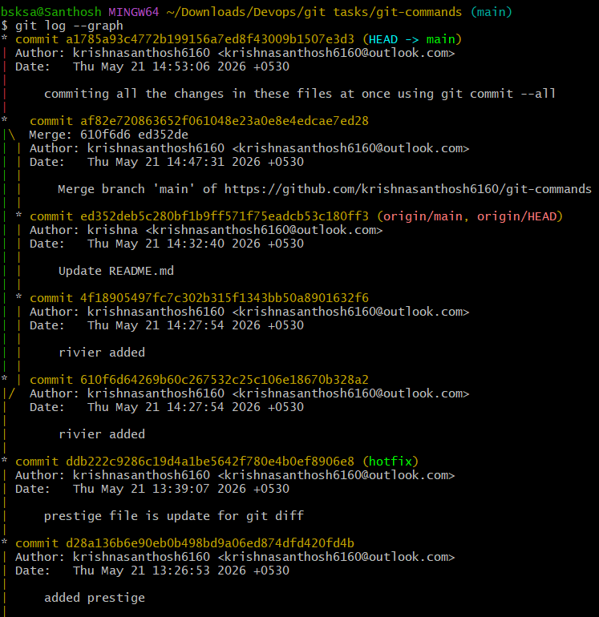

- git log --author="name": Filters commits by a specific author.

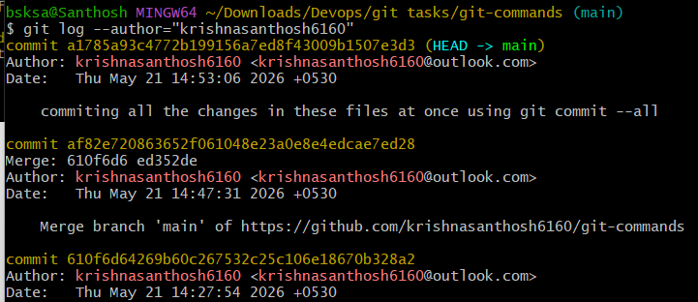

- git log --since="2 weeks ago": Filters commits made after a specific date.

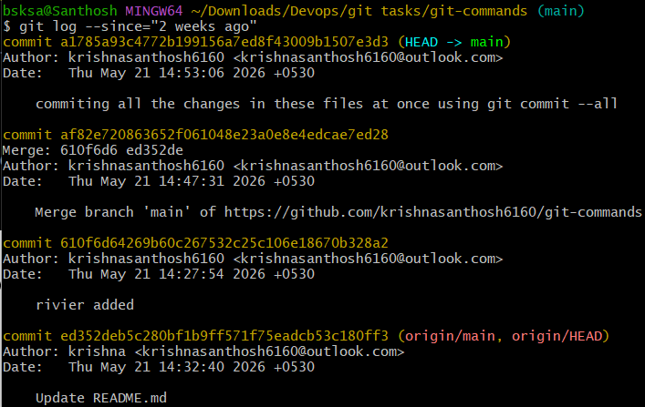

- git blame: Shows line-by-line annotations for a file, telling who last modified each line.

- git show <commit_id>: Shows details of a specific commit (including diff and metadata).

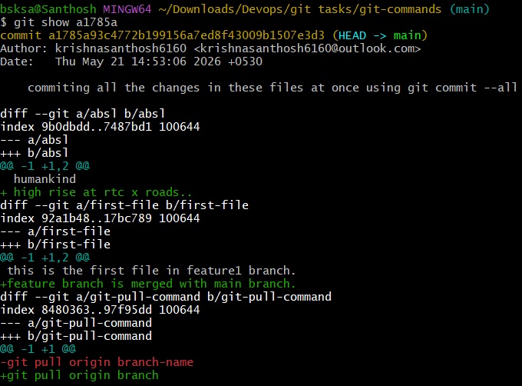

- git show <commit_id>:<file_path>: Shows a specific file at a particular commit.

6. Reverting and Resetting (Undoing changes)

- git reset <commit_id>: Moves HEAD to a specific commit, leaving your working directory intact (can be used with --soft, -mixed, or --hard).

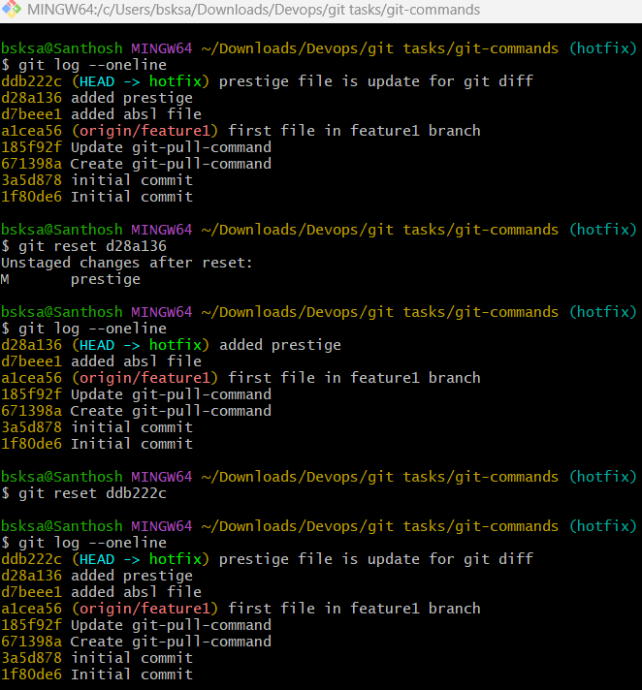

- git reset --hard <commit_id>: Resets your working directory, index, and HEAD to a specific commit (all changes will be lost).

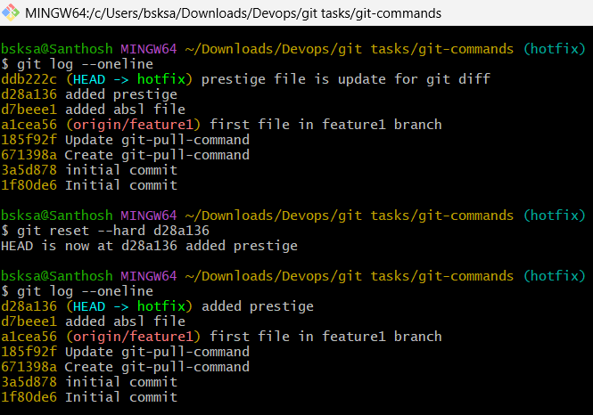

- git reset --soft <commit_id>: Resets only the HEAD to a specific commit, leaving staged changes.

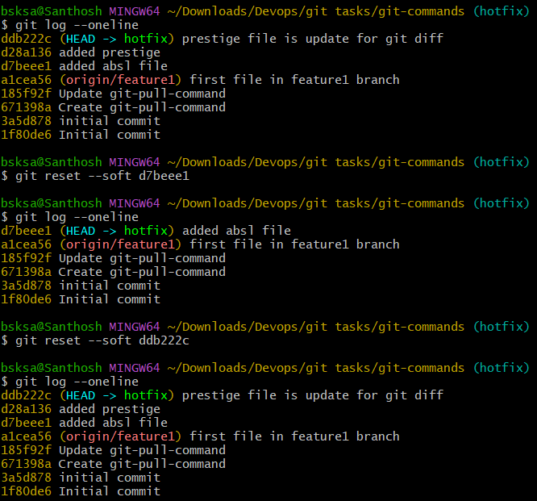

- git reset --mixed <commit_id>: Resets the HEAD and index to a specific commit but keeps the working directory unchanged.

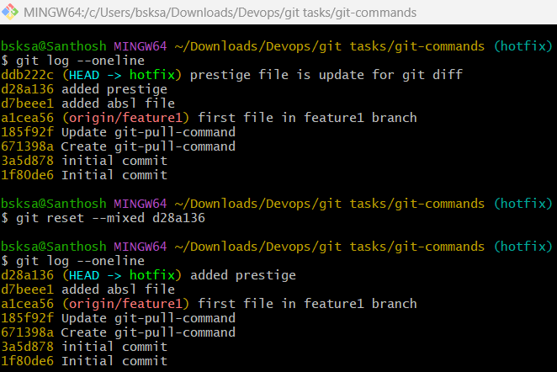

- git revert <commit_id>: Creates a new commit that undoes the changes of the specified commit.

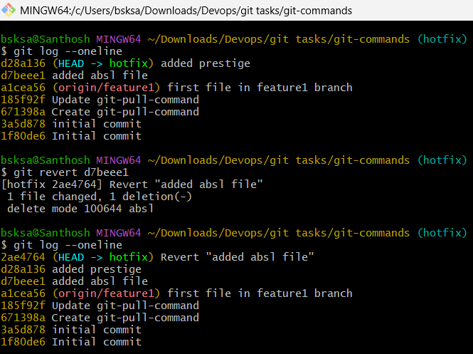

- git restore: Restores the file(s) in the working directory from the index or a commit.

- git restore --staged: Removes a file from the staging area.

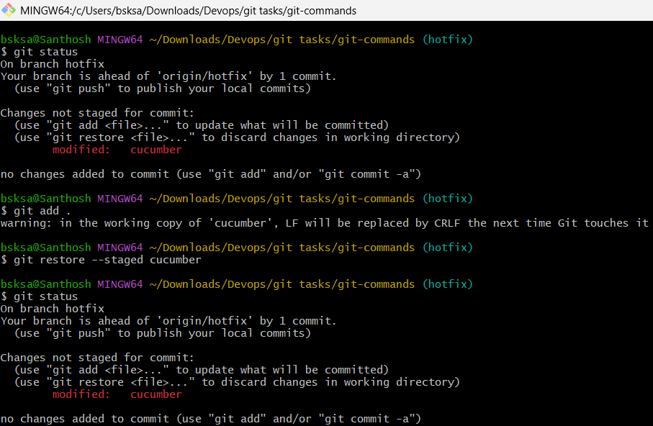

- git clean -f: Removes untracked files in the working directory.
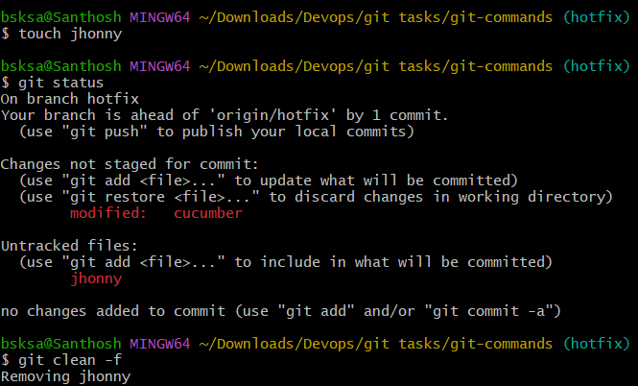

- git clean -fd: Removes untracked files and directories.

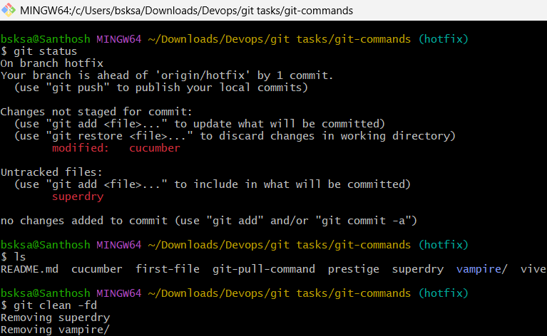

7. Stashing (Temporarily saving changes)
- git stash: Stashes the changes in your working directory (both staged and unstaged).

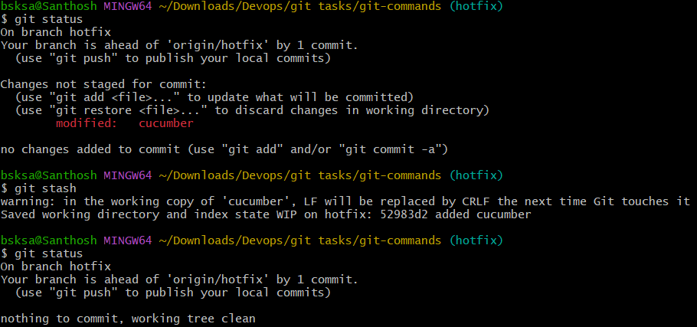

- git stash list: Lists all the stashes.

- git stash pop: Applies the latest stash and removes it from the stash list.

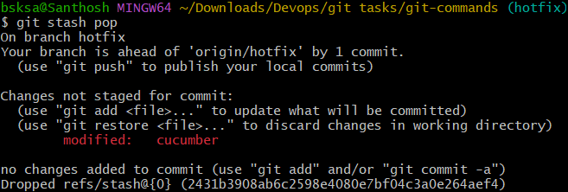

- git stash apply: Applies a stash without removing it from the list.

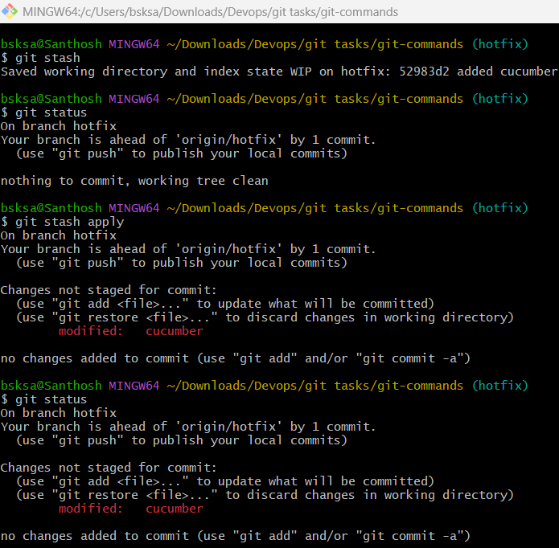

- git stash drop: Removes a specific stash from the stash list.

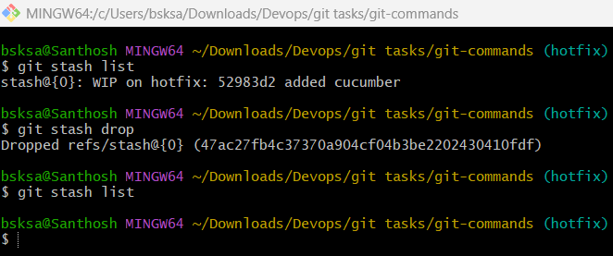

- git stash clear: Clears all stashes.

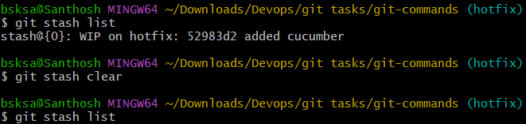

- git stash save "message": Stashes changes with an optional message for identification.

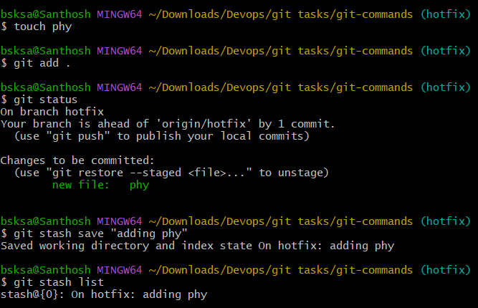

- git stash branch <branch_name>: Creates a new branch from the stash and applies it.

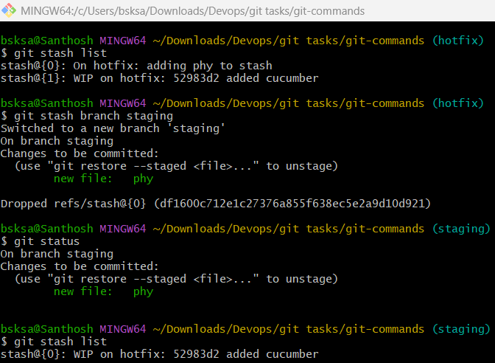

8. Tags (Managing versions)

- git tag: Lists all tags in the repository.

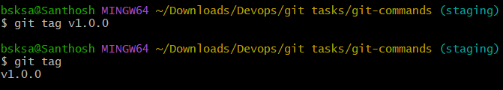

- git tag <tag_name>: Creates a new tag at the current commit.

- git tag -a <tag_name> -m "message": Creates an annotated tag with a message.

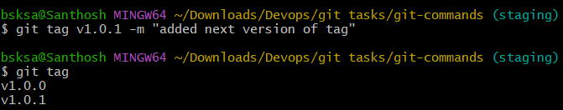

- git tag -d <tag_name>: Deletes a tag locally.

- git push origin <tag_name>: Pushes a specific tag to the remote repository.

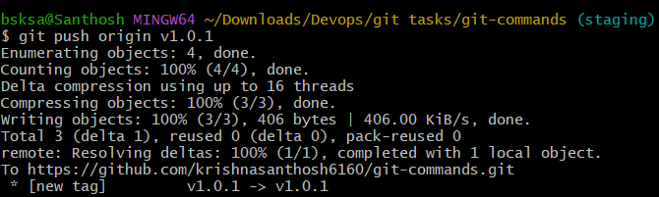

- git push origin --tags: Pushes all tags to the remote repository.

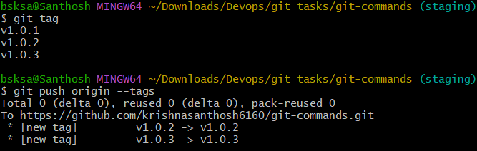

- git fetch --tags: Fetches all tags from the remote repository.

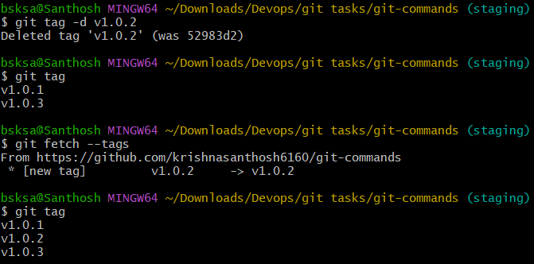

9. Git Config and Info (Configuration and repository information)

- git config --global user.name "Your Name": Sets your global username for commits.

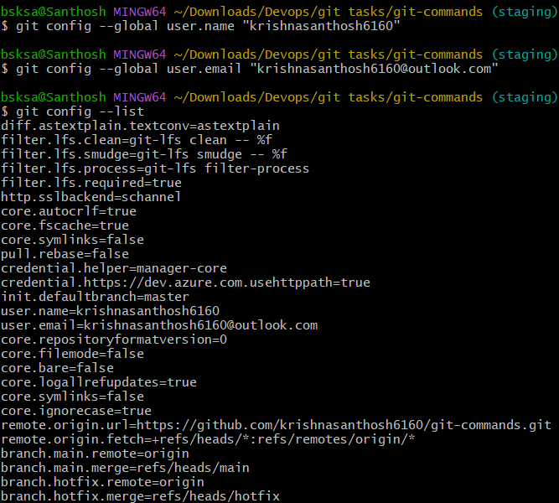

- git config --global user.email "youremail@example.com": Sets your global email for commits.



- git config --list: Lists all configuration settings.



- git config: Sets a specific configuration option.

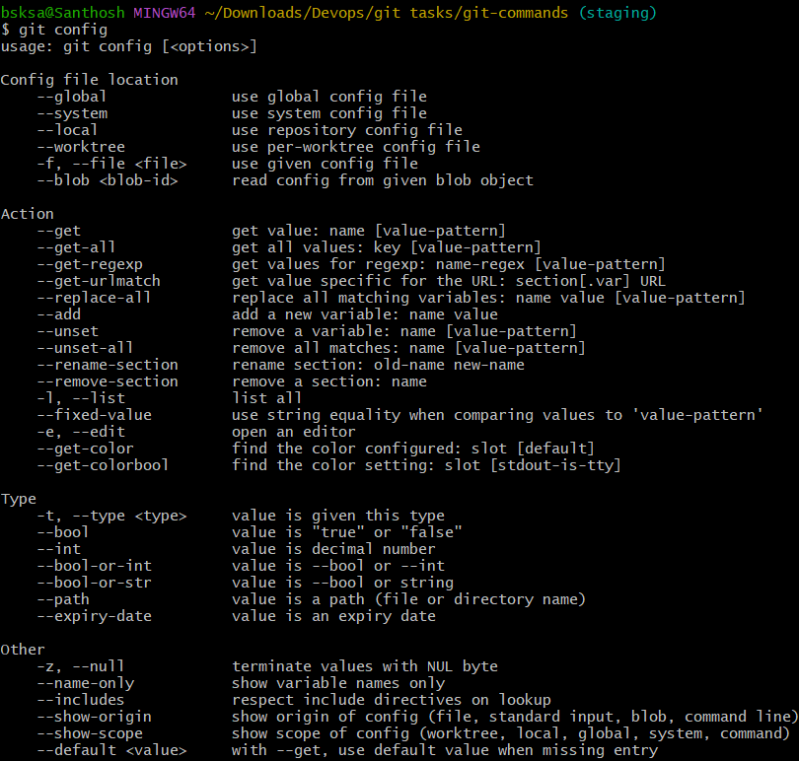

- git config --global core.editor : Sets the default text editor for Git.

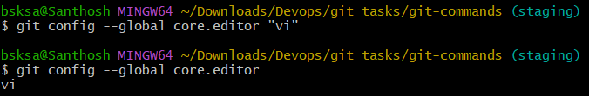

- git config --global color.ui true: Enables colored output in Git.

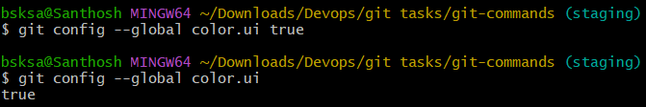

- git config --global alias.st status: Creates a custom Git alias (e.g., git st for git status).

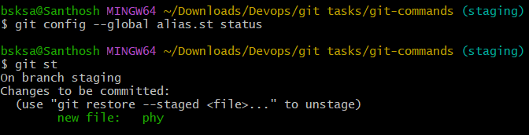

10. Git Aliases (Custom commands)

- git config --global alias.<alias_name><actual_command>: Creates a new Git alias for an existing command.
  - Example: git config --global alias.co checkout

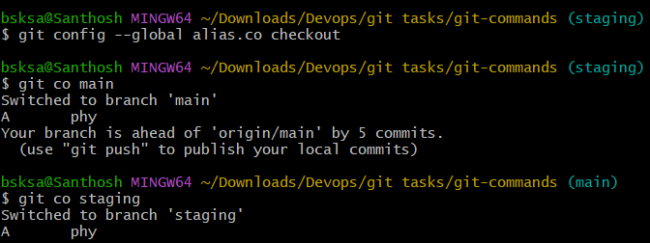

11. Git Hooks (Automated scripts triggered by Git actions)

- git init: Creates a .git/hooks directory, where hook scripts are stored.

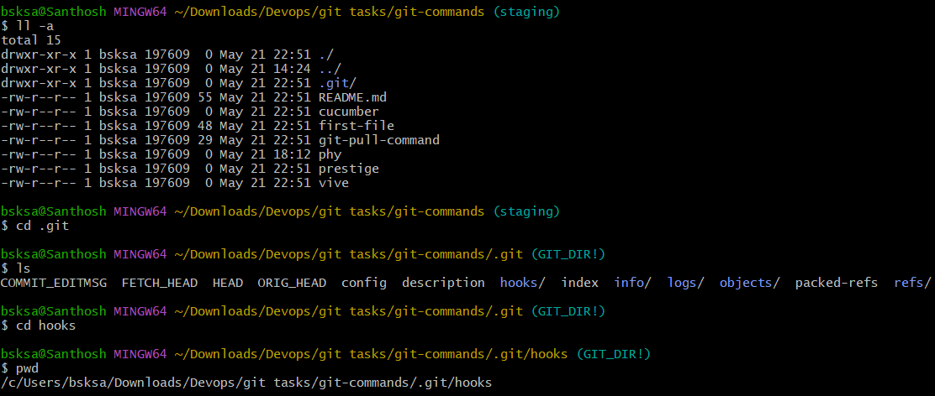

- git commit-msg: A hook that runs before a commit message is saved (you can use this to enforce message formats).

- git pre-commit: A hook that runs before a commit is made (can be used for checks like linting).

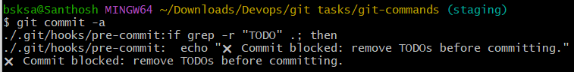

- git post-commit: A hook that runs after a commit is made.

12. Git Submodules (Managing external repositories within a project)

- git submodule add <repo_url>: Adds a new submodule to the repository (downloads an external repo).

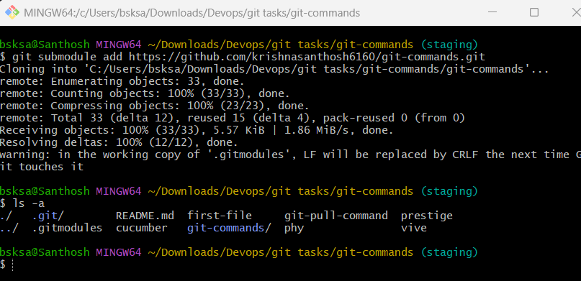

- git submodule init: Initializes the submodules configured in the repository (after cloning).

- git submodule update: Updates the submodules to the commit specified in the superproject.
- git submodule status: Displays the current commit of the submodule.
- git submodule deinit: Removes a submodule from the working directory.
- git submodule update --remote: Updates the submodule to the latest commit from the remote repository.
- git submodule foreach: Runs a command in each submodule.

